JSON REFINER-ADVANCED EDITION

Naan Mudhalvan Project Report Submitted to Manonmaniam Sundaranar University in the Partial fulfilment of the Requirement for the award of the Degree of Bachelor of Science in Information Technology.
Submitted By
TEAM ID: SWTID-2026-3623
TEAM LEADER : A. FATHIMA BASRIN | - 23082241808412010
TEAM MEMBER : K.M. FATHIMA FAHADHA | - 23082241808412011
TEAM MEMBER : Z. NASOOKA | - 23082241808412031
TEAM MEMBER : M. SHAFRIN FATHIMA | - 23082241808412041



DEPARTMENT OF INFORMATION TECHNOLOGY
WAVOO WAJEEHA WOMEN’S COLLEGE OF ARTS & SCIENCE
KAYALPATNAM – 628 204
APRIL – 2026

CERTIFICATE

WAVOO WAJEEHA WOMEN’S COLLEGE OF ARTS AND SCIENCE
KAYALPATNAM – 628 204
CERTIFICATE
This is to certify that project entitled as
JSON REFINER-ADVANCED EDITION
Is a bonafide work done by
TEAM ID: SWTID-2026-3623
TEAM LEADER: A. FATHIMA BASRIN - 23082241808412010
TEAM MEMBER: K.M. FATHIMA FAHADHA - 23082241808412011
TEAM MEMBER: Z. NASOOKA - 23082241808412031
TEAM MEMBER: M. SHAFRIN FATHIMA - 23082241808412041

In partial fulfilment of the requirement for B.Sc. Degree Course in Information Technology (2025-2026) of the Manonmaniam Sundaranar University for Naan Mudhalvan Course (Agentic AI Application Developer) is done.

Signature of the Staff In charge Signature of the H.O.D

EXTERNAL EXAMINERS:
1.

2.

DECLARATION

DECLARATION
This project is submitted for the Naan Mudhalvan Course Agentic AI Application Developer Subject code, and the external examination is conducted on___.

Signature of the Candidates

1. A. FATHIMA BASRIN

2. K.M. FATHIMA FAHADHA

3. Z. NASOOKA

4. M. SHAFRIN FATHIMA

DATE:
PLACE: Kayalpatnam

CONTENT

TABLE OF CONTENTS

S.NO | TITLE | PAGE NO
1. | PROJECT DESCRIPTION | 1
2. | SCENARIO | 3
3. | ARCHITECTURE OVERVIEW | 5
4. | PROJECT WORKFLOW | 8
5. | PROJECT STRUCTURE | 11
6. | IMPLEMENTATION PHASE | 13
7. | SCREENSHOTS | 30
8. | CONCLUSION | 36
9. | FUTURE ENHANCEMENTS | 38

PROJECT DESCRIPTION

PROJECT DESCRIPTION

JSON Refiner Advanced Edition is an intelligent platform developed to process and refine JSON data efficiently. It uses the powerful data handling capabilities of Python to perform operations such as JSON parsing, validation, transformation, and refinement. The system provides a user-friendly interface using Gradio, allowing users to easily interact with and manage JSON data.

The main goal of this platform is to improve the quality and standardization of JSON data formats. It offers several advanced features such as AI-assisted JSON generation, automatic detection of data types, schema validation, key case conversion, and flattening or unflattening of JSON structures. These features help users produce clean and well-structured JSON outputs suitable for real-world applications.
The system analyzes unstructured key-value input data and automatically identifies the appropriate data types such as strings, numbers, booleans, null values, arrays, and objects. It also applies consistent naming styles like snake_case, camelCase, kebab-case, and PascalCase to maintain uniformity in JSON keys.

In addition, JSON Refiner Advanced provides validation against JSON schemas to ensure the accuracy and correctness of data. If any errors or inconsistencies are found, the system reports them clearly to the user. The platform combines a modern Gradio interface with advanced processing algorithms, enabling users to handle complex JSON transformations while maintaining data integrity and reliability.

SCENARIOS

SCENARIOS

Scenario 1: Converting CSV Data to JSON
A data analyst may need to transform a CSV file containing mixed data values into a structured JSON format. In this situation, the system accepts key-value data from the CSV file such as name, age, status, and score. It automatically identifies the correct data types, applies a consistent naming format, and generates clean JSON output. The analyst can also validate the generated data using a predefined schema before storing it in a database.

Scenario 2: Standardizing API Responses
Backend developers often receive JSON responses from multiple APIs that use different naming conventions and structures. The system helps by converting all keys into a single case style, such as snake_case or camelCase. It can combine multiple API responses into one structured format, remove empty or null values, and validate the data using a schema. This process reduces manual effort in application development.

Scenario 3: Managing Configuration Files
DevOps engineers sometimes maintain configuration settings in simple text formats. These configurations must often be converted into JSON format for automation tools. The system reads the configuration values, detects the correct data types, checks for duplicate keys, and ensures all required fields are present. Finally, it produces valid JSON output ready for deployment systems.

Scenario 4: Flattening JSON Data for Analysis
Analytics teams may work with deeply nested JSON structures that are difficult to analyze in spreadsheet tools. The system can flatten nested objects into a simple dot notation format so that the data becomes easier to use in tools such as Excel or CSV files. When needed, the system can also convert the flattened data back into its original nested structure.

Scenario 5: Validating Data with JSON Schema
Quality assurance teams need to ensure that JSON data follows company standards. The system allows users to validate JSON data against predefined JSON schemas. It checks whether the required fields exist and whether the data types are correct. If errors are found, detailed messages are displayed so they can be corrected before the data issued in applications.

ARCHITECTURE OVERVIEW

- ARCHITECTURE OVERVIEW

Architecture Overview
JSON Refiner Advanced is designed using a modular architecture that combines a Python backend with advanced JSON processing techniques. The system focuses on providing reliable data transformation, a smooth user experience, and accurate validation. The Gradio interface allows users to interact with the system through an easy-to-use web interface..

Core Technologies
. Python 3.8+ – Main programming language used for processing JSON data.
. Gradio – Provides an interactive web interface for users.
. JSON5 – Allows flexible parsing of JSON inputs.
. JSON Schema – Used to validate JSON structure and data types.
. Regular Expressions – Helps in pattern matching during data parsing.
. Google Colab – Used for development and cloud execution.
. HTML5 / CSS3 – Used for designing the interface layout.

Pre-requisites

Software Requirements
. Python 3.8 or later
. Google account for accessing Google Colab
. pip package manager
. Modern web browser such as Chrome or Firefox
. Internet connection for running the interface

Knowledge Prerequisites

. Python Basics: Functions, dictionaries, list comprehensions, string manipulation

. JSON Fundamentals: JSON structure, types, and validation

. Regular Expressions: Pattern matching for data parsing

. Gradio Framework: Understanding of interface components and callbacks

. Data Validation: Familiarity with JSON Schema and validation concepts

. Google Colab: Basic notebook interface and cell execution

Hardware Requirements

. Processor: Minimum Intel i3 or equivalent
. RAM: At least 2 GB
. Storage: Around 500 MB free space
. Display resolution: Minimum 1024 × 768

PROJECT WORKFLOW

PROJECT WORKFLOW

Phase 1: Environment Setup
In this phase, all required libraries and tools are installed. The Google Colab environment is prepared and dependencies such as Gradio, JSON5, JSONSchema, and other Python libraries are configured. Core data structures and classes are designed to manage JSON processing operations.

Phase 2: JSON Processing Engine Development
This phase focuses on building the main processing functions. The system implements automatic type detection to convert values into correct JSON data types such as boolean, integer, float, or string. It also develops methods for key normalization and case conversion to ensure consistent naming styles.

Phase 3: Validation and Transformation
Additional features such as JSON schema validation and required field checking are implemented. The system also includes transformation functions like flattening nested JSON, reversing flattened data, merging multiple JSON objects, and removing null values.

Phase 4: Interface Development
In this phase, the Gradio user interface is created. Input fields, buttons, and output panels are designed to allow users to interact with the JSON processing system. Different tabs are added for refining data, validation, case conversion, merging JSON objects, and flattening operations.

Phase 5: Testing and Deployment
Finally, the application is tested using multiple scenarios to ensure correct functionality. Case conversion, schema validation, merging operations, and flattening features are tested with different JSON inputs.
After successful testing, the system is deployed using Google Colab.

TECHNICAL ARCHITECTURE

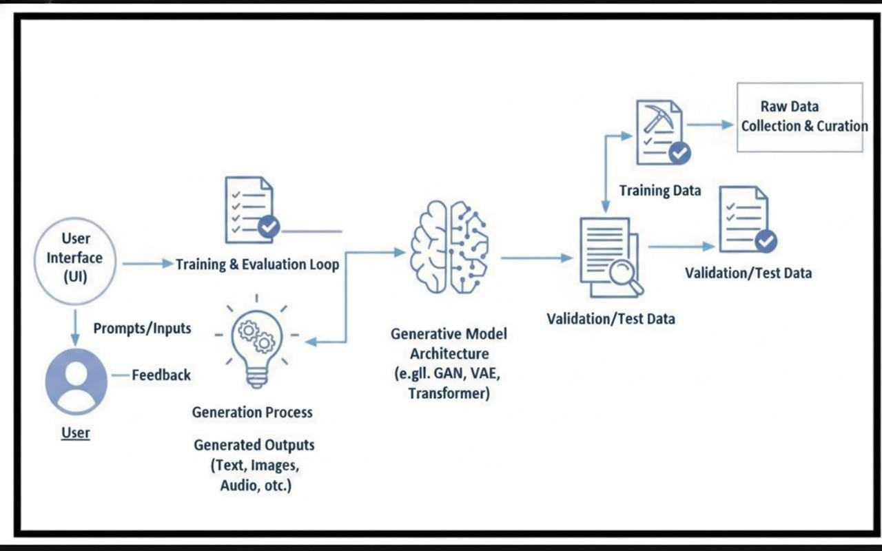

PROJECT STRUCTURE

- PROJECT STRUCURE

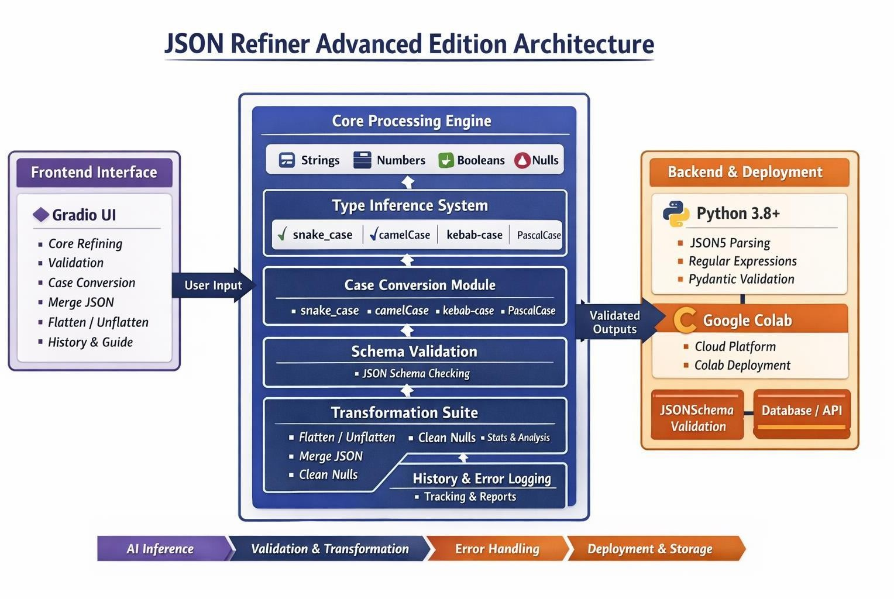

IMPLEMENTATION PHASE

- IMPLEMENTATION PHASE

Activity 1.1: Install Dependencies
!pip install -U transformers
# Use a pipeline as a high-level helper from transformers import pipeline
pipe = pipeline("text-generation", model="ibm-granite/granite-3.3-2b-instruct") messages = [
{"role": "user", "content": "Who are you?"},
]
pipe(messages)
# Load model directly
from transformers import AutoTokenizer, AutoModelForCausalLM
tokenizer = AutoTokenizer.from_pretrained("ibm-granite/granite-3.3-2b-instruct")
model = AutoModelForCausalLM.from_pretrained("ibm-granite/granite-3.3-2b-instruct") messages = [
{"role": "user", "content": "Who are you?"},
]
inputs = tokenizer.apply_chat_template( messages, add_generation_prompt=True, tokenize=True,
return_dict=True, return_tensors="pt",
).to(model.device)
outputs = model.generate(**inputs, max_new_tokens=40) print(tokenizer.decode(outputs[0][inputs["input_ids"].shape[-1]:]))
!pip install -q --upgrade gradio json5 jsonschema python-dotenv pydantic import gradio as gr
import json import re
import ast
from datetime import datetime from pathlib import Path from typing import Dict, List, Any, Tuple, Optional import json5
from jsonschema import validate, ValidationError, Draft7Validator from enum import Enum

Activity 1.2: Initialize Enum and Core Class

class CaseStyle(Enum):
"""Case conversion styles""" SNAKE_CASE = "snake_case" CAMEL_CASE = "camelCase" KEBAB_CASE = "kebab-case" PASCAL_CASE = "PascalCase" class JSONRefinerCore:
"""Advanced JSON parsing and refinement engine""" def _init_(self):
self.conversion_log = [] self.validation_errors = [] self.transformation_history = [] @staticmethod
def to_snake_case(text: str) -> str: """Convert text to snake_case""" text = re.sub(r'[\s\-]+', '_', text)
text = re.sub(r'([a-z])([A-Z])', r'\1_\2', text)
text = re.sub(r'[^a-zA-Z0-9_]', '', text) return text.lower()
@staticmethod
def to_camel_case(text: str) -> str: """Convert text to camelCase""" snake =
JSONRefinerCore.to_snake_case(text) parts = snake.split('_')
return parts[0].lower() + ''.join(word.capitalize() for word in parts[1:])
@staticmethod
def to_kebab_case(text: str) -> str: """Convert text to kebab-case""" snake = JSONRefinerCore.to_snake_case(text) return snake.replace('_', '-') @staticmethod
def to_pascal_case(text: str) -> str: """Convert text to PascalCase""" camel = JSONRefinerCore.to_camel_case(text) return camel[0].upper() + camel[1:] if camel else ""
@staticmethod
def normalize_key(key: str, case_style: CaseStyle = CaseStyle.SNAKE_CASE) -
> str: """Normalize key name""" key = key.strip()

if case_style == CaseStyle.SNAKE_CASE: return JSONRefinerCore.to_snake_case(key)
elif case_style == CaseStyle.CAMEL_CASE:
return JSONRefinerCore.to_camel_case(key) elif case_style == CaseStyle.KEBAB_CASE: return JSONRefinerCore.to_kebab_case(key) elif case_style == CaseStyle.PASCAL_CASE: return JSONRefinerCore.to_pascal_case(key) return key

Activity 2.1: Implement Type Inference
@staticmethod
def infer_type(value: str) -> Any:
"""Infer and convert value to correct JSON type""" value = value.strip()
if value.lower() in ['null', 'none', 'nil', 'undefined', 'n/a', 'na']: return None
if value.lower() in ['true', 'yes', 'on', '1']:
return True
if value.lower() in ['false', 'no', 'off', '0']:
return False try:
if '.' not in value:
return int(value) except ValueError:
pass try:
return float(value) except ValueError:
pass
if value.startswith('[') and value.endswith(']'):
try:
return json.loads(value) except:
pass
if value.startswith('{') and value.endswith('}'): try:
return json.loads(value) except:
pass
return value

Activity 2.2: Build Case Conversion Methods
def convert_case(json_text: str, target_case: str) -> Tuple[str, str]: """Convert JSON keys to different case styles"""
try:
data = json.loads(json_text)

case_enum = CaseStyle[target_case.upper().replace('-', '_')] def convert_keys(obj):
if isinstance(obj, dict):
return {
refiner.normalize_key(k, case_enum): convert_keys(v) for k, v in obj.items()
}
elif isinstance(obj, list):
return [convert_keys(item) for item in obj] return obj
converted = convert_keys(data)
output = json.dumps(converted, indent=2, ensure_ascii=False) return output, f"✅ Converted to {target_case}!"
except Exception as e:
return "", f"❌ Error: {str(e)}"
def merge_multiple_json(json_text1: str, json_text2: str, json_text3: str = "") -> Tuple[str, str]: """Merge multiple JSON objects"""
try:
objects = []
for json_text in [json_text1, json_text2, json_text3]:
if json_text.strip():
objects.append(json.loads(json_text)) if not objects:
return "", "❌ No JSON objects to merge" merged = refiner.merge_json_objects(*objects)
output = json.dumps(merged, indent=2, ensure_ascii=False) return output, f"✅ Merged {len(objects)} JSON objects!" except Exception as e:
return "", f"❌ Error: {str(e)}"

Activity 3.1: JSON Parsing & Validation
@staticmethod
def parse_key_value_text(text: str, case_style: CaseStyle = CaseStyle.SNAKE_CASE) -> Tuple[Dict, List[str]]:
"""Parse key-value text into dictionary""" result = {}
errors = [] duplicates = []
lines = text.split('\n')
for line_num, line in enumerate(lines, 1):
line = line.strip()
if not line or line.startswith('#'):
continue
if ':' not in line:
errors.append(f"Line {line_num}: No colon separator found - '{line}'") continue
try:
key, value = line.split(':', 1)

key = key.strip() value = value.strip() if not key:
errors.append(f"Line {line_num}: Empty key found") continue
normalized_key = JSONRefinerCore.normalize_key(key, case_style) if normalized_key in result:
duplicates.append(f"Line {line_num}: Duplicate key '{normalized_key}' (original: '{key}')") continue
converted_value = JSONRefinerCore.infer_type(value) result[normalized_key] = converted_value
except Exception as e:
errors.append(f"Line {line_num}: Parse error - {str(e)}") all_errors = errors + duplicates
return result, all_errors

Activity 3.2: Schema & Field validation
@staticmethod
def validate_json_schema(data: Dict, schema: Dict) -> Tuple[bool, List[str]]: """Validate JSON against schema"""
errors = [] try:
validate(instance=data, schema=schema) return True, []
except ValidationError as e:
return False, [str(e)] except Exception as e:
return False, [f"Schema validation error: {str(e)}"] @staticmethod
def check_required_fields(data: Dict, required_fields: List[str]) -> Tuple[bool, List[str]]: """Check for required fields"""
errors = [] missing = []
for field in required_fields:
if field not in data: missing.append(field) if missing:
return False, [f"Missing required fields: {', '.join(missing)}"] return True, []

Activity 3.3: JSON Transformation Operations
@staticmethod
def flatten_json(data: Dict, parent_key: str = '', sep: str = '.') -> Dict:
"""Flatten nested JSON""" items = []
for k, v in data.items():
new_key = f"{parent_key}{sep}{k}" if parent_key else k

if isinstance(v, dict): items.extend(JSONRefinerCore.flatten_json(v, new_key, sep=sep).items())
elif isinstance(v, list): items.append((new_key, v)) else: items.append((new_key, v)) return dict(items) @staticmethod
def unflatten_json(data: Dint, sep: str = '.') -> Dict: """Unflatten dot-notation JSON"""
result = {}
for key, value in data.items():
parts = key.split(sep) current = result
for part in parts[:-1]:
if part not in current:
current[part] = {} current = current[part]
current[parts[-1]] = value return result @staticmethod
def merge_json_objects(*objects: Dict) -> Dict: """Deep merge multiple JSON objects"""
result = {}
for obj in objects:
for key, value in obj.items():
if key in result and isinstance(result[key], dict) and isinstance(value, dict):
result[key] = JSONRefinerCore.merge_json_objects(result[key], value)
else:
result[key] = value return result @staticmethod
def remove_null_values(data: Dict, recursive: bool
=
True) -> Dict:
"""Remove null/None values from JSON""" if not recursive:
return {k: v for k, v in data.items() if v is not None}
result = {}
for k, v in data.items():
if v is None:
continue
elif isinstance(v, dict):
result[k] = JSONRefinerCore.remove_null_values(v,

recursive=True) else:
result[k] = v return result @staticmethod
def get_json_stats(data: Dict) -> Dict[str, Any]: """Get statistics about JSON structure"""
def count_items(obj):
if isinstance(obj, dict):
return len(obj), sum(count_items(v)[0] for v in obj.values())
elif isinstance(obj, list):
return len(obj), sum(count_items(item)[0] if isinstance(item, (dict, list)) else 0 for item in obj) return 0, 0
top_level, total = count_items(data) return {
'top_level_keys': top_level, ' total_keys': total,
'has_nested_objects': any(isinstance(v, dict) for v in data.values()),
'has_arrays': any(isinstance(v, list) for v in data.values()),
'has_null_values': any(v is None for v in data.values()),
'value_types': list(set(type(v)._name_ for v in data.values()))
}
# Initialize core engine refiner = JSONRefinerCore() transformation_history = []
def refine_json(text_input: str, case_style: str = "snake_case", remove_nulls: bool = False, flatten: bool = False, pretty_print: bool = True) -> Tuple[str, str, str]:
"""Main refinement function""" global transformation_history if not text_input.strip():
return "", "❌ Empty input provided!", "" try:
case_enum = CaseStyle[case_style.upper().replace('- ', '_')]
parsed_data, parse_errors = refiner.parse_key_value_text(text_input, case_enum)
if remove_nulls:
parsed_data = refiner.remove_null_values(parsed_data) if flatten:

parsed_data = refiner.flatten_json(parsed_data) if pretty_print:
json_output = json.dumps(parsed_data, indent=2, ensure_ascii=False)
else:
json_output = json.dumps(parsed_data, ensure_ascii=False)
stats = refiner.get_json_stats(parsed_data) stats_text = f"""
📊 *JSON Statistics:*
- Top-level Keys: {stats['top_level_keys']}
- Total Keys: {stats['total_keys']}
- Has Nested Objects: {stats['has_nested_objects']}
- Has Arrays: {stats['has_arrays']}
- Has Null Values: {stats['has_null_values']}
- Value Types: {', '.join(stats['value_types'])} """
status_msg = "✅ Successfully converted to JSON!" if parse_errors:
status_msg += f"\n\n⚠️ *Warnings ({len(parse_errors)}):*\n"
status_msg += "\n".join(f"• {err}" for err in parse_errors[:5])
if len(parse_errors) > 5:
status_msg += f"\n• ... and {len(parse_errors) - 5} more errors"
transformation_history.append({ 'timestamp': datetime.now().isoformat(), 'input': text_input,
'output': json_output, 'errors': parse_errors, 'stats': stats
})
return json_output, status_msg, stats_text except Exception as e:
return "", f"❌ Error: {str(e)}", ""
def validate_json(json_text: str, schema_text: str = "", required_fields: str = "") -> Tuple[str, str]: """Validate JSON against schema or required fields"""
try:
data = json.loads(json_text) validation_results = []
if required_fields.strip():
fields = [f.strip() for f in required_fields.split(',')] is_valid, errors = refiner.check_required_fields(data, fields)
if not is_valid: validation_results.extend(errors) else:

validation_results.append("✅ All required fields present")
if schema_text.strip():
schema = json.loads(schema_text)
is_valid, errors = refiner.validate_json_schema(data, schema)
if not is_valid: validation_results.extend(errors) else:
validation_results.append("✅ Schema validation passed")
if not validation_results: validation_results.append("✅ Valid JSON structure")
result_text = "\n".join(f"• {res}" for res in validation_results)
return result_text, "✅ Validation complete!" except json.JSONDecodeError as e:
return f"❌ Invalid JSON: {str(e)}", "❌ JSON parse error"
except Exception as e:
return f"❌ Error: {str(e)}", "❌ Validation error" def convert_case(json_text: str, target_case: str) -> Tuple[str, str]:
"""Convert JSON keys to different case styles""" try:
data = json.loads(json_text) case_enum =
CaseStyle[target_case.upper().replace('-', '_')] def convert_keys(obj):
if isinstance(obj, dict):
return {
refiner.normalize_key(k, case_enum): convert_keys(v)
for k, v in obj.items()
}
elif isinstance(obj, list):
return [convert_keys(item) for item in obj] return obj
converted = convert_keys(data)
output = json.dumps(converted, indent=2, ensure_ascii=False)
return output, f"✅ Converted to {target_case}!" except Exception as e:
return "", f"❌ Error: {str(e)}"
def merge_multiple_json(json_text1: str, json_text2: str, json_text3: str = "") -> Tuple[str, str]:
"""Merge multiple JSON objects""" try:

objects = []
for json_text in [json_text1, json_text2, json_text3]: if json_text.strip(): objects.append(json.loads(json_text))
if not objects:
return "", "❌ No JSON objects to merge" merged = refiner.merge_json_objects(*objects) output = json.dumps(merged, indent=2, ensure_ascii=False)
return output, f"✅ Merged {len(objects)} JSON objects!"
except Exception as e:
return "", f"❌ Error: {str(e)}"
def flatten_json_func(json_text: str) -> Tuple[str, str]:
"""Flatten JSON structure""" try:
data = json.loads(json_text) flattened = refiner.flatten_json(data)
output = json.dumps(flattened, indent=2, ensure_ascii=False)
return output, "✅ JSON flattened!" except Exception as e:
return "", f"❌ Error: {str(e)}"
def unflatten_json_func(json_text: str) -> Tuple[str, str]:
"""Unflatten JSON structure""" try:
data = json.loads(json_text)
unflattened = refiner.unflatten_json(data) output = json.dumps(unflattened, indent=2, ensure_ascii=False)
return output, "✅ JSON unflattened!" except Exception as e:
return "", f"❌ Error: {str(e)}" def clear_history():
"""Clear transformation history""" global transformation_history transformation_history = []
return "✅ History cleared!" def download_history() -> str:
"""Download transformation history""" if not transformation_history:
return "❌ No history to download"
report = "JSON REFINER - TRANSFORMATION HISTORY\n"
report += f"Generated:
{datetime.now().strftime('%Y-%m-%d
%H:%M:%S')}\n"

report += "="*80 + "\n\n"
for i, item in enumerate(transformation_history, 1): report += f"Transformation #{i}\n"
report += f"Timestamp: {item['timestamp']}\n" report += f"Input:\n{item['input']}\n\n"
report += f"Output:\n{item['output']}\n\n" if item['errors']:
report += f"Errors: {', '.join(item['errors'])}\n\n" report += "-"*80 + "\n\n"
return report
print("🚀 Loading JSON Refiner Advanced...") with gr.Blocks(
title="JSON Refiner - Advanced Edition"
) as demo:
demo.load(None, js=""" () => {
document.body.style.background = 'linear- gradient(135deg, #0f172a 0%, #1e293b 100%)'; const style = document.createElement('style'); style.textContent = `
:root {
--primary-color: #667eea;
--secondary-color: #f5576c;
}
body {
background: linear-gradient(135deg, #0f172a 0%, #1e293b 100%) !important;
font-family: 'Segoe UI', Tahoma, Geneva, Verdana, sans-serif;
}
.gradio-container {
background: linear-gradient(135deg, #0f172a 0%, #1e293b 100%) !important;
max-width: 1400px !important;
}
h1, h2, h3 { color: #f1f5f9 !important; }
. code-block { background: #1e293b !important; border: 2px solid #667eea !important; }
`;
document.head.appendChild(style);
} """)
gr.Markdown("""
# 🎯 JSON Refiner Advanced Edition ## Professional JSON Processing Tool
*Features:* Type Inference • Schema Validation • Case Conversion • Flattening • Merging • History Tracking
""")

with gr.Tabs():

Activity 4.1: Gradio Interface development
# ============= TAB 1: Core Refining =============
with gr.TabItem("🔧 Core Refining"):
with gr.Row():
with gr.Column(scale=1):
gr.Markdown("### 📝 Input Format") text_input = gr.Textbox(
label="Key-Value Text", lines=12,
value="name: John Doe\nage: 28\nis_active: true\nbalance: 1500.50\nemail: john@example.com\ntags: [\"admin\", \"user\"]\nmetadata: {\"level\": 5}"
)
case_style = gr.Radio(
["snake_case", "camelCase", "kebab-case", "PascalCase"], value="snake_case",
label="🎨 Key Case Style"
)
with gr.Row():
remove_nulls = gr.Checkbox(label="Remove Nulls", value=False) flatten = gr.Checkbox(label="Flatten", value=False)
pretty_print = gr.Checkbox(label="Pretty Print", value=True)
refine_btn = gr.Button("✨ Refine JSON", size="lg", variant="primary") with gr.Column(scale=1):
gr.Markdown("### 📊 Output") json_output = gr.Code( language="json", label="Refined JSON", lines=12
)
status_text = gr.Markdown(label="Status") stats_text = gr.Markdown(label="Statistics") refine_btn.click(
refine_json,
inputs=[text_input, case_style, remove_nulls, flatten, pretty_print], outputs=[json_output, status_text, stats_text]
)
# ============= TAB 2: Validation =============
with gr.TabItem("✅ Validation"):

gr.Markdown("### 🔍 Validate JSON Structure") with gr.Row():
with gr.Column(scale=1):
json_to_validate = gr.Code( language="json", label="JSON to Validate", lines=10,
value='{"name": "John", "age": 28}'
required_fields_input = gr.Textbox( label="Required Fields (comma-separated)", value="name, age, email"
)
with gr.Column(scale=1):
schema_input = gr.Code( language="json",
label="JSON Schema (optional)", lines=10,
value='{"type": "object", "properties": {"name": {"type": "string"}}}'
)
validate_btn = gr.Button("🔍 Validate", size="lg", variant="primary") validation_results = gr.Markdown(label="Validation Results") validation_status = gr.Markdown()
validate_btn.click( validate_json,
inputs=[json_to_validate, schema_input, required_fields_input], outputs=[validation_results, validation_status]
)
# ============= TAB 3: Case Conversion =============
with gr.TabItem("🎨 Case Conversion"): gr.Markdown("### 🔄 Convert JSON Key Cases") with gr.Row():
with gr.Column(scale=1):
json_for_case = gr.Code( language="json", label="Input JSON", lines=10,
value='{"firstName": "John", "lastName": "Doe"}'
)
target_case = gr.Radio(
["snake_case", "camelCase", "kebab-case", "PascalCase"], value="camelCase",
label="Target Case Style"
)

case_convert_btn = gr.Button("🔄 Convert", size="lg", variant="primary") with gr.Column(scale=1):
case_output = gr.Code( language="json", label="Converted JSON", lines=10
)
case_status = gr.Markdown() case_convert_btn.click( convert_case, inputs=[json_for_case, target_case], outputs=[case_output, case_status]
)
# ============= TAB 4: Merging =============
with gr.TabItem("  Merge JSON"): gr.Markdown("### 🔀 Merge Multiple JSON Objects") with gr.Row():
with gr.Column(scale=1):
json1 = gr.Code( language="json", label="JSON #1", lines=8,
value='{"name": "John"}'
)
json2 = gr.Code(
language="json", label="JSON #2", lines=8, value='{"age": 28}'
)
json3 = gr.Code( language="json", label="JSON #3 (optional)", lines=8,
value='{"email": "john@example.com"}'
)
merge_btn = gr.Button("  Merge", size="lg", variant="primary") with gr.Column(scale=1):
merge_output = gr.Code( language="json", label="Merged JSON", lines=10
)
merge_status = gr.Markdown()

merge_btn.click( merge_multiple_json, inputs=[json1, json2, json3],
outputs=[merge_output, merge_status]
)

# ============= TAB 5: Flattening =============
with gr.TabItem("📋 Flatten/Unflatten"):
with gr.Tabs():
with gr.TabItem("Flatten"):
gr.Markdown("### 📦 Flatten Nested JSON") with gr.Row():
flatten_input = gr.Code( language="json", label="Nested JSON", lines=10,
value='{"user": {"name": "John", "age": 28}}'
)
flatten_btn = gr.Button("Flatten", size="lg", variant="primary") flatten_out = gr.Code(
language="json", label="Flattened JSON", lines=10
)
flatten_status = gr.Markdown() flatten_btn.click( flatten_json_func, inputs=[flatten_input],
outputs=[flatten_out, flatten_status]
)
with gr.TabItem("Unflatten"):
gr.Markdown("### 📦 Unflatten Dot-Notation JSON") with gr.Row():
unflatten_input = gr.Code( language="json", label="Flattened JSON", lines=10,
value='{"user.name": "John", "user.age": 28}'
)
unflatten_btn = gr.Button("Unflatten", size="lg", variant="primary") unflatten_out = gr.Code(
language="json",

label="Nested JSON", lines=10
)
unflatten_status = gr.Markdown() unflatten_btn.click( unflatten_json_func, inputs=[unflatten_input],
outputs=[unflatten_out, unflatten_status]
)
# ============= TAB 6: History =============
with gr.TabItem("📜 History"):
gr.Markdown("### 📊 Transformation History") with gr.Row():
history_btn = gr.Button("📥 Download History", size="lg", variant="secondary") clear_history_btn = gr.Button("🗑️ Clear History", size="lg", variant="stop") history_output = gr.Textbox(
label="History Report", lines=15
)
history_status = gr.Markdown() history_btn.click( download_history, outputs=[history_output]
)
clear_history_btn.click( clear_history, outputs=[history_status]
)
# ============= TAB 7: Guide =============
with gr.TabItem("📚 Guide"): gr.Markdown("""
# 📖 JSON Refiner - Complete Guide ## Input Format
Use simple *Key: Value* format:
name: John Doe age: 28 is_active: true balance: 1500.50
print("\n✅ JSON Refiner Advanced Ready!\n") demo.launch(share=True, show_error=True, show_api=False)

SCREENSHOTS

- SCREENSHOTS

A Google Colab Deployment

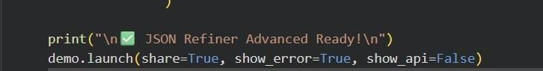

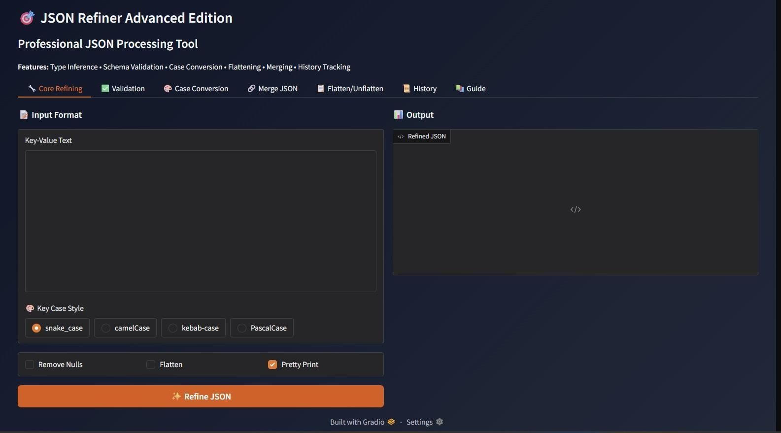

Functional Testing

Test Case 1: Basic Key-Value Conversion
Input: name: John Doe age: 28 active: true balance: 1500.50 input:

INPUT:

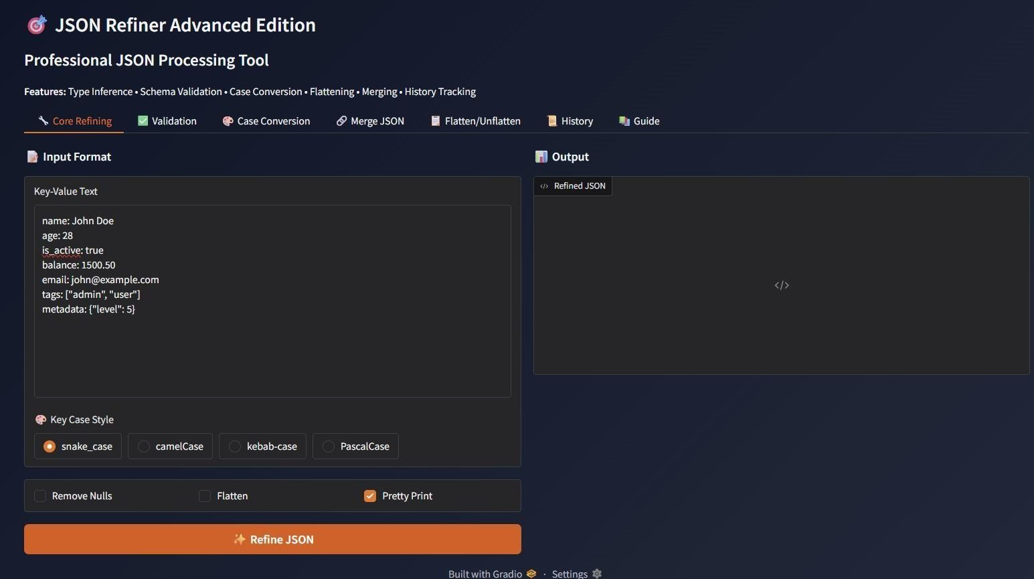

OUTPUT:

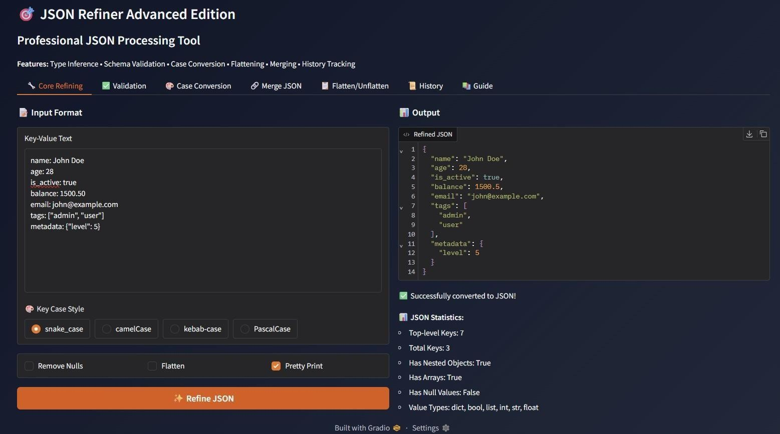

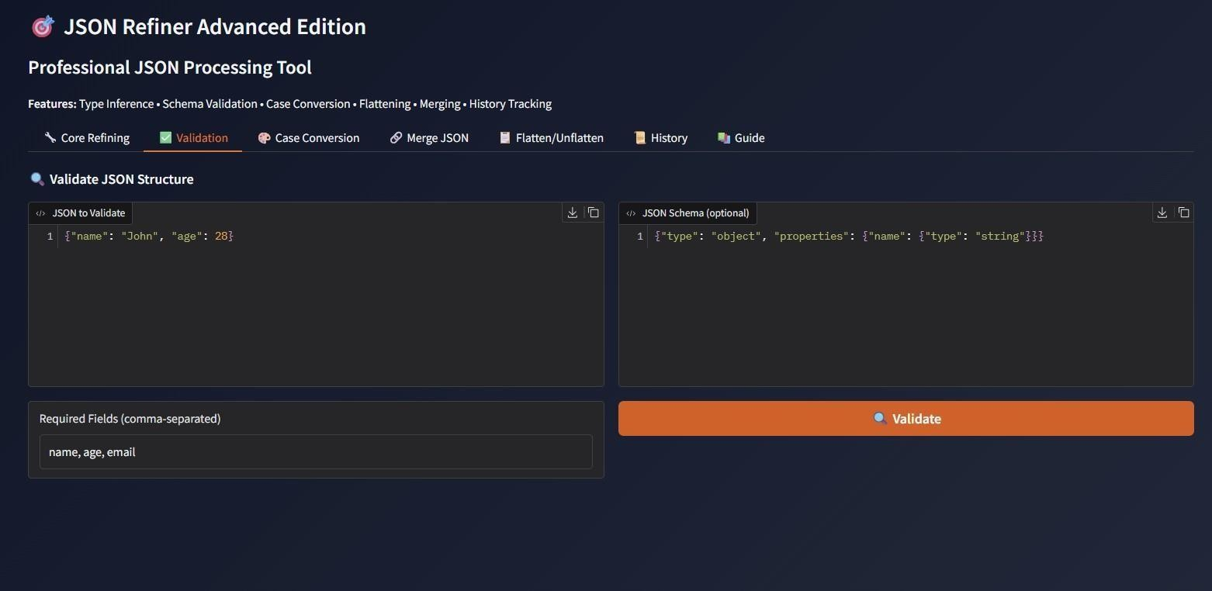

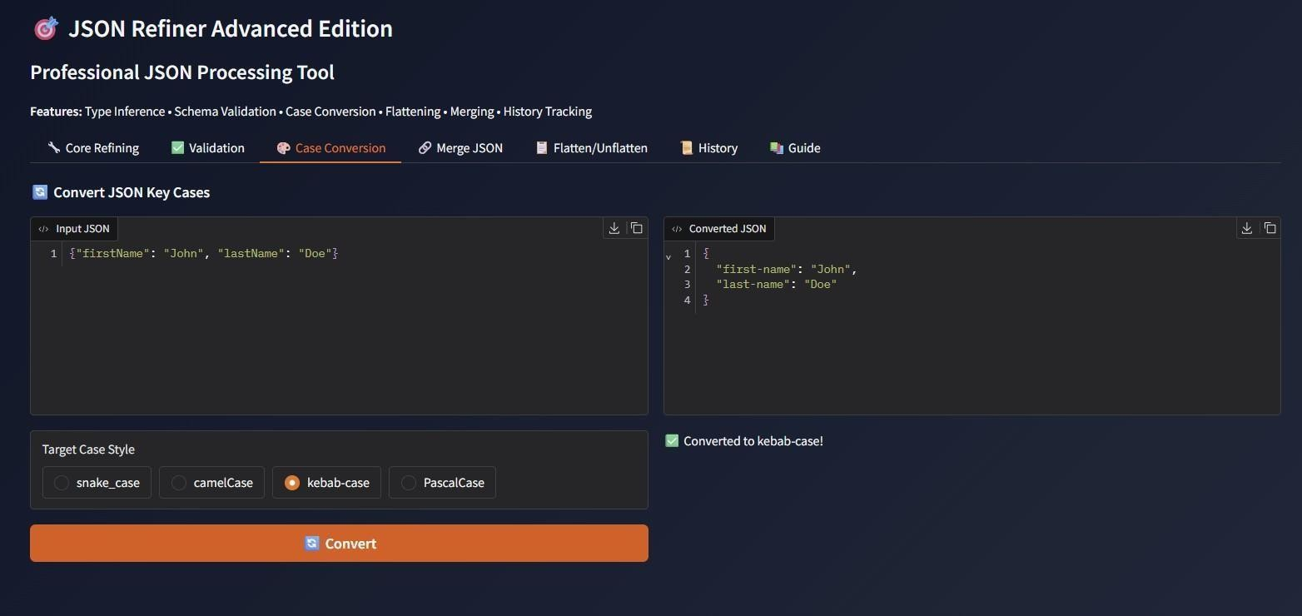

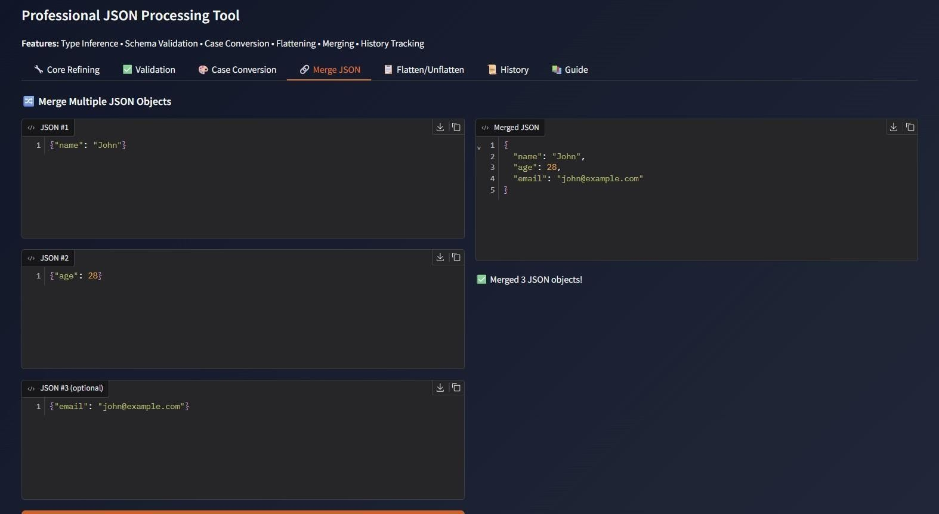

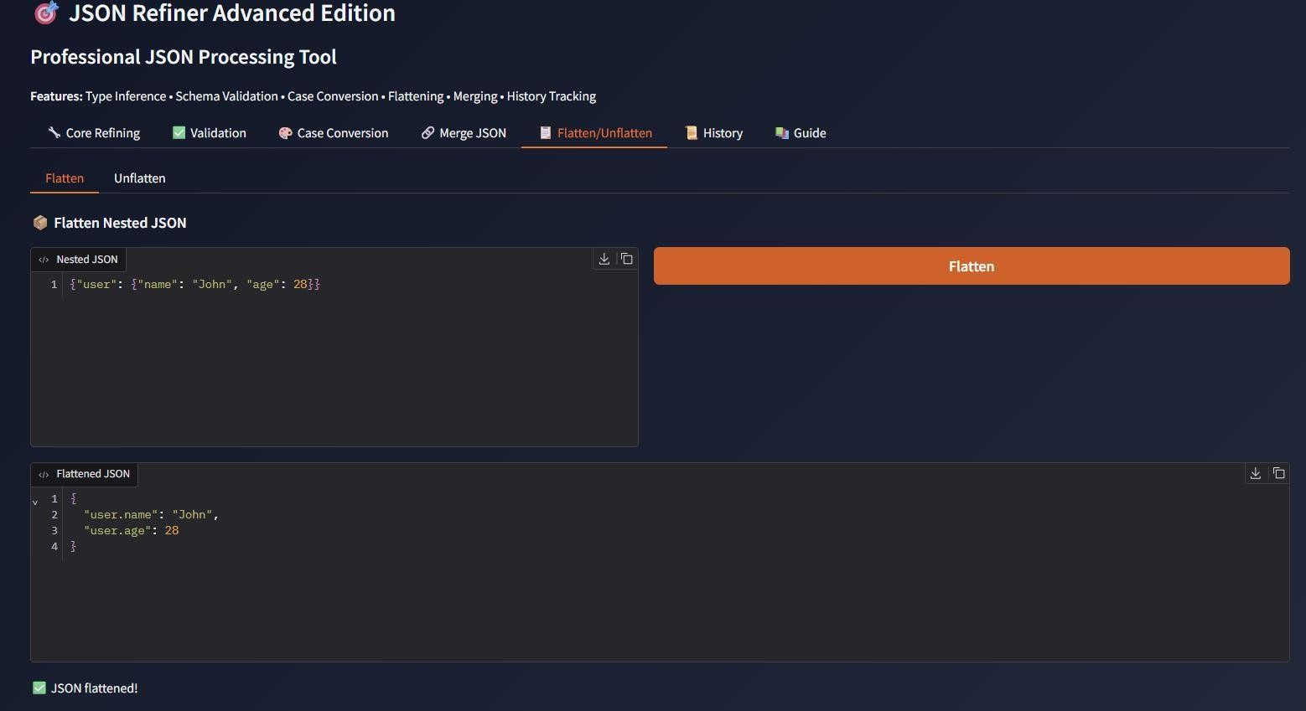

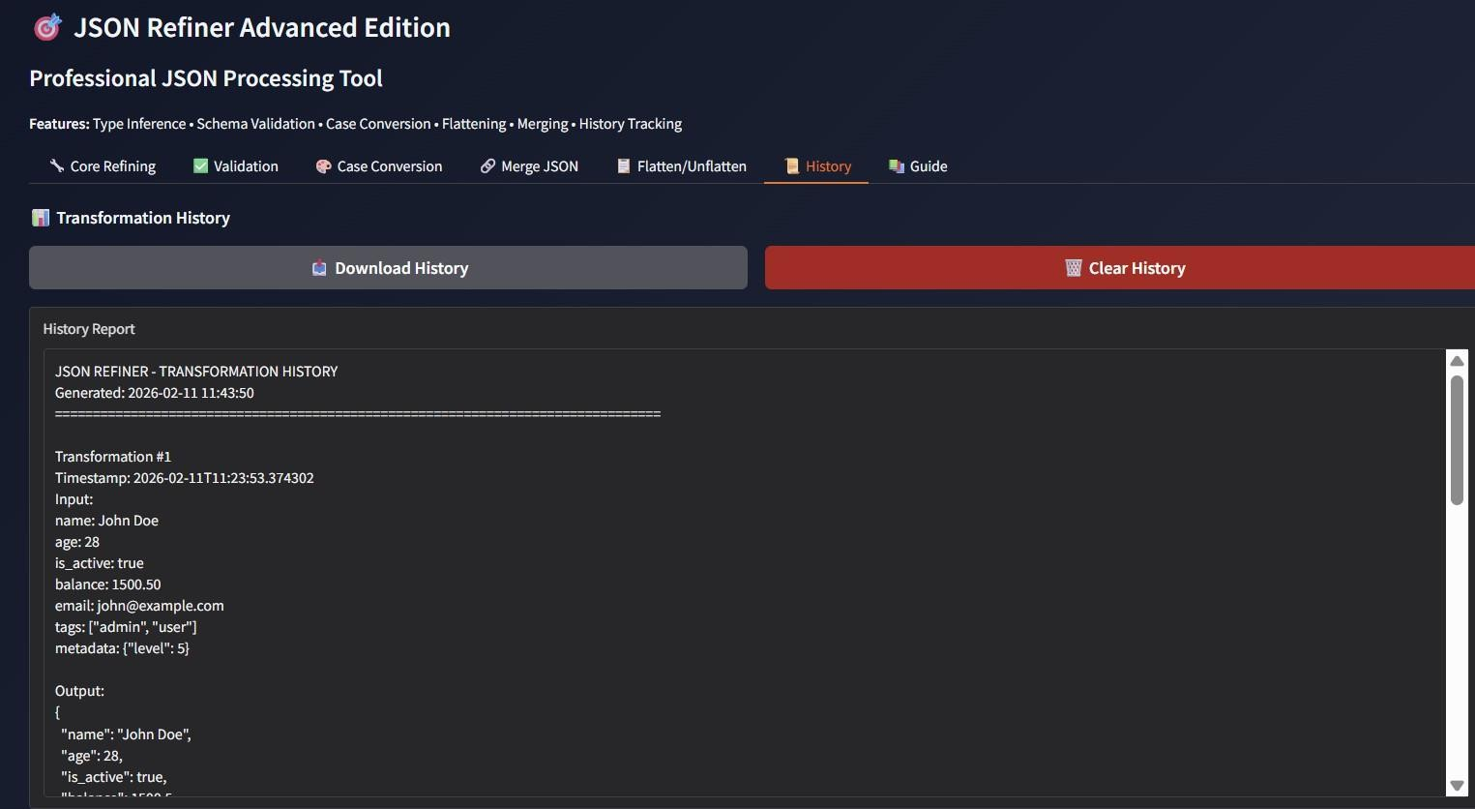

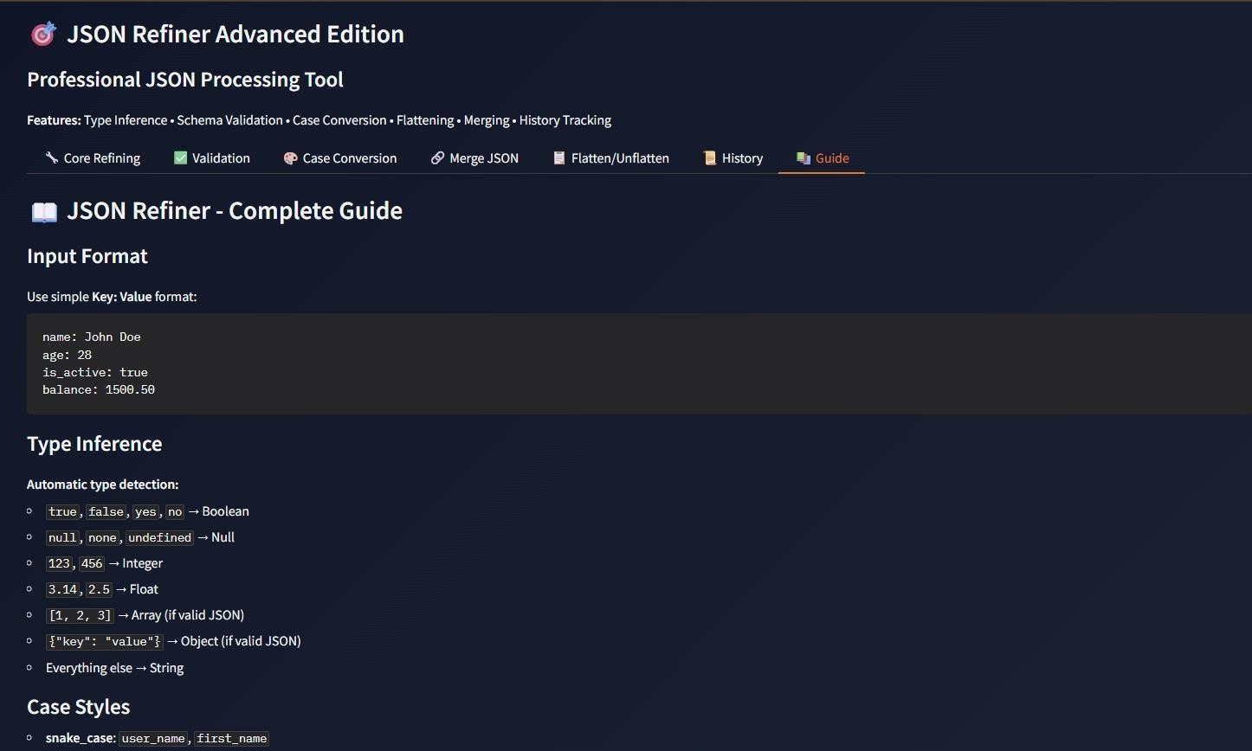

CONCLUSION

8. CONCLUSION

JSON Refiner Advanced Edition provides an efficient solution for processing and managing JSON data. By combining Python’s powerful data processing capabilities with the interactive Gradio interface, the platform makes JSON transformation simple and accessible for both technical and non-technical users.

The system successfully demonstrates how automated tools can simplify complex data processing tasks. With features such as automatic type detection, case conversion, schema validation, and advanced JSON transformations, the platform helps users generate accurate and well-structured JSON outputs.

Overall, the project improves productivity in handling JSON data while maintaining high standards of data accuracy and reliability..

FUTURE ENHNCEMENTS

FUTURE ENHANCEMENTS

The system can be extended in the future with several additional features. New transformation rules and advanced data extraction methods using regular expressions can be added. Integration with popular data analysis libraries such as Pandas and NumPy can improve data processing capabilities.

Future versions may also include batch processing of large datasets, API generation features, and customizable validation rules. Machine learning techniques can be introduced to improve automatic type detection and data prediction. Integration with cloud storage services can also allow large-scale JSON data management.

With further improvements, JSON Refiner Advanced has the potential to become a complete data processing platform supporting multiple data formats while maintaining simplicity and ease of use.

